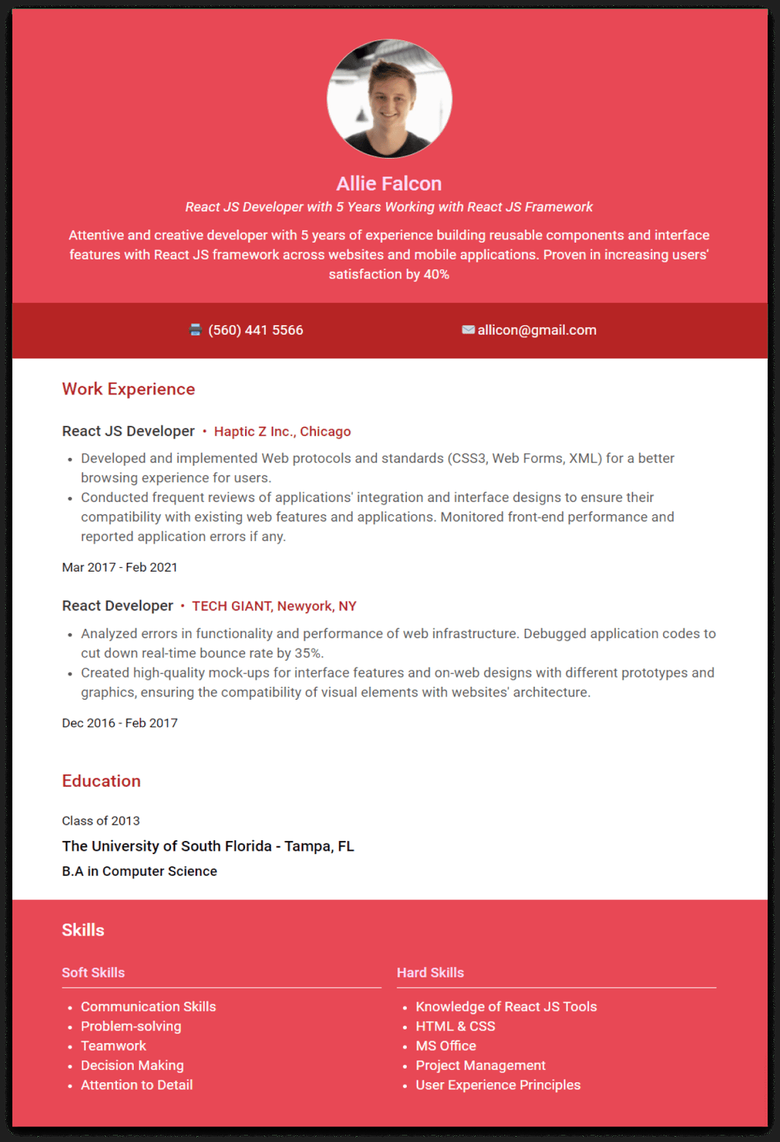
Allie Falcon
React JS Developer with 5 Years Working with React JS Framework
Attentive and creative developer with 5 years of experience building reusable components and interface features with React JS framework across websites and mobile applications. Proven in increasing users' satisfaction by 40%
Work Experience
(560) 441 5566
allicon@gmail.com
React JS Developer⚫ Haptic Z Inc., Chicago
.
•
Developed and implemented Web protocols and standards (CSS3, Web Forms, XML) for a better browsing experience for users.
Conducted frequent reviews of applications' integration and interface designs to ensure their compatibility with existing web features and applications. Monitored front-end performance and reported application errors if any.
Mar 2017 - Feb 2021
React Developer⚫ TECH GIANT, Newyork, NY
• Analyzed errors in functionality and performance of web infrastructure. Debugged application codes to cut down real-time bounce rate by 35%.
• Created high-quality mock-ups for interface features and on-web designs with different prototypes and graphics, ensuring the compatibility of visual elements with websites' architecture.
Dec 2016 - Feb 2017
Education
Class of 2013
The University of South Florida - Tampa, FL
B.A in Computer Science
Skills
Soft Skills
.
•
Communication Skills
Problem-solving
Teamwork
Decision Making
• Attention to Detail
Hard Skills
• Knowledge of React JS Tools
• HTML & CSS
• MS Office
• Project Management
• User Experience Principles

